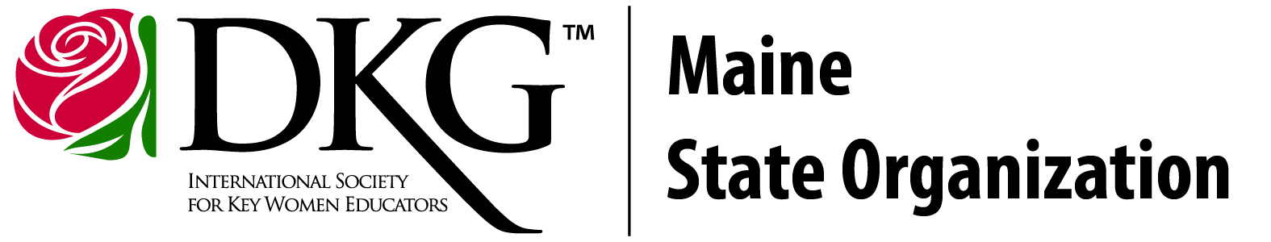
S-T-R-E-T-C-H Your Teaching Workshop
Saturday, April 6, 2024
United Technologies Center - Bangor, Maine

Name: __________________________________ School: _____________________________

Email address: ______________________________________________

Please write your first and second choices for workshops.

Session 1: 1) _____________________________ 2) _____________________________
Session 2: 1) _____________________________ 2) _____________________________

Please check and pay the registration fee that is applicable:
_______ Early registration fee (before Mar. 8th) $35.00
_______ Registration fee (after Mar. 8th) $45.00
_______ Pre-Service Teachers: $15.00 - Name of your College: ________________________
_______ DKG members: $25.00 - Name of your Chapter: _________________________
_______ Presenter: No fee
As part of the registration fee, lunch WILL be provided.
A certificate for 5.5 Contact Hours will be provided.
To be guaranteed a lunch of a sandwich, chips, dessert, and beverage, the registration deadline is March 22, 2024.

Please note: Due to the solar eclipse on Apr. 8, hotel rooms in the Bangor area may be in demand. We have arranged for a block of rooms at the Bangor Hampton Inn for both Friday night the 5th and Saturday night the 6th. The rate of $115.00 per night includes a continental breakfast. To receive this rate, you must use the group code DKG and reserve by Mar. 22, 2024. Call (207) 300-0151.

For general questions and to request dietary accommodations, please contact the workshop coordinator at mishyland@gmail.com.

Three ways to submit payment:
1. Personal check payable to Maine State DKG and mail with payment.
2. School purchase order payable to Maine State DKG. Please bring a school check on the workshop day.
3. EventBrite (online registration)
https://www.eventbrite.com/e/s-t-r-e-t-c-h-your-teaching-workshop-tickets-815995694087?aff=oddtdtcreator

Or use QR codes:
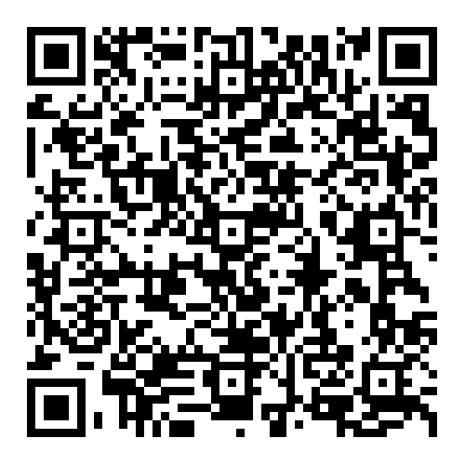 For Eventbrite For MSO website with registration forms

Send your registration to: Donna Kennison
3 Forbes Road
West Paris, ME 04289
If you choose, you can email your registration to: mimiken7@gmail.com and send your fee via snail mail. If you have any questions regarding workshop registration,
please contact registrar Donna Kennison.

Sponsored by the Maine State Organization of DKG International, a professional organization of women educators promoting professional and personal growth and excellence in education.

